Calculating PID variables

A bump test was performed, where the change in heater temperature as a result of relay output was measured. The results can be found in the PID calibration excel file, but are summarized in the chart below.

The process variables that are of most importance to calculating the PID variables are Kp, the gain; Tp, the time constant; and sigma p, the dead time.

Based in the below graph, the following information about the 5% bump was determined:

|  |  |
| --- | --- |
| ‘t0 | 2:36:25.1 |
| ‘t1 | 3:36:33.6 |
| Delta t | 1:00:08.5 |
| ‘t0.63 | 3:01:00.4 |
| T0 | 26.10 |
| T1 | 71.90 |
| deltaT | 45.80 |
| T0.63 | 54.95 |
| Initial reaction t | 2:36:42:4 |
| Sigma p | 0:00:17.3 |
| Kp=change in process variable/change in control output | =45.80C / 5% =9.16 |
| Tp (63% time – dead time) | 24:18.0 |

Tc, process time, is the larger of a multiple of Tp or sigma p.

|  |  |  |
| --- | --- | --- |
|  | Relating to Tp | Relating to sigma p |
| Aggressive | * 1. Tp   00:02:25.8 | 0.8 sigma  00:00:13.8 |
| Moderate | Tp 00:24:18.0 | 8 sigma  00:02:18.4 |
| Conservative | 10 Tp 04:02:59.7 | 80 sigma  00:23:03.9 |

These are used to calculate the variables Kc, Ti, and Td

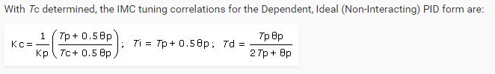

For the aggressive, moderate and conservative values, first expressed in minutes, than in seconds, where I is Kc/Ti and D is Kc*Td.

|  |  |  |  |
| --- | --- | --- | --- |
|  | Kc | I | D |
| Aggressive | 1.036234649 | 0.042396235 | 0.14594904 |
| Moderate | 0.109170306 | 0.004466566 | 0.015376152 |
| Conservative | 0.010974278 | 0.000448999 | 0.001545678 |

|  |  |  |  |
| --- | --- | --- | --- |
|  | Kc | I | D |
| Aggressive | 1.036234649 | 0.000706604 | 8.756942384 |
| Moderate | 0.109170306 | 7.44428E-05 | 0.922569109 |
| Conservative | 0.010974278 | 7.48331E-06 | 0.092740693 |

May also try the depending interacting form:

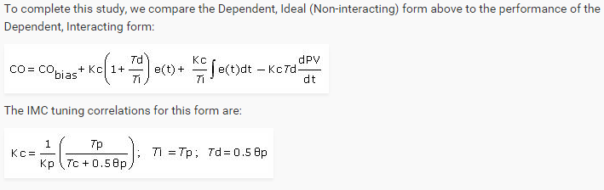

Where Kc*(1+Td/Ti) = P, Kc/Ti = I, and Kc*Td = D

****THESE ARE THE SAME VALUES????? WEIRD

Minutes

|  |  |  |  |
| --- | --- | --- | --- |
|  | P | I | D |
| Aggressive | 1.036234649 | 0.042396235 | 0.14594904 |
| Moderate | 0.109170306 | 0.004466566 | 0.015376152 |
| Conservative | 0.010974278 | 0.000448999 | 0.001545678 |

Seconds

|  |  |  |  |
| --- | --- | --- | --- |
|  | P | I | D |
| Aggressive | 1.036234649 | 0.000706604 | 8.756942384 |
| Moderate | 0.109170306 | 7.44428E-05 | 0.922569109 |
| Conservative | 0.010974278 | 7.48331E-06 | 0.092740693 |

Try p-only first. P values of 1, 2, 10 all increase VERY slowly. With P=100, increases at reasonable rate, Overshoots by a small amount, then settles at a temp less than the setpoint. When P=200, a sinusoidal curve can be observed. Similar thing happened with 200 – larger overshoot, larger oscillations. On closer inspection, oscillations significant. Try P=50, 25, etc… 5000 actually hit 55, the goal temp.

Sustained repeating oscillations at 400. Ku = 400, Pu = 1:06.0 (based on 10 cycles from 39:43.5 to 50:43.7.

 from contrl guru

So Kc = 180, Ti= 33 seconds.

Get pid from values - <http://controlguru.com/pid-control-of-the-heat-exchanger/>

Dead time – http://controlguru.com/dead-time-is-the-how-much-delay-variable/

Kp - http://controlguru.com/process-gain-is-the-how-far-variable/

Tp - <http://controlguru.com/process-gain-is-the-how-fast-variable-2/>

Want initial P to be before any oscialltion occurs.

Chose P=100

Then add small increments of I until it starts to oscillate.

